



**Lewis N. Stoddard, Bar No. 7766 Halliday, Watkins & Mann, P.C. 376 East 400 South, Suite 300 Salt Lake City, UT 84111**

**Phone: 801-355-2886**

**Facsimile; 801-328-9714** [**lewis@hwmlawfirm.com**](mailto:lewis@hwmlawfirm.com)

**Attorney for Plaintiff** I **HWM File No. 1021698**

**Electronically Fifed 7/9/2024 11 :13 AM**

**Second Judicial District, Nez Perce County Patty Weeks, Clerk of the Cour1**

**By: Amber Gurney, Deputy Clerk**

**IN THE DISTRICT COURT OF THE SECOND JUDICIAL DISTRICT OF THE STATE OF IDAHO IN AND FOR THE COUNTY OF NEZ PERCE**



**DPW Enterprises LLC and Mountain Prime 2018 LLC,**



**Plaintiff,**

# v.

**Jeremy L. Bass, Dwayne Pike, and Current occupant; and Unknown Parties in Possession of the real property commonly known as 1515 21st Ave., Lewiston, ID 83501,**

### I CV35-24-1063

**Case No.:**

---------

**POST FORECLOSURE COMPLAINT FOR EJECTMENT AND RESTITUTION OF PROPERTY**

**Fee Category A Filing Fee $221**

  

**The plaintiff, by and through its attorneys of record, hereby complains and alleges as follows:**

**I.**

**By virtue of a foreclosure sale, plaintiff is the owner of real property located at 1515 21st Ave., Lewiston, ID 83501, ('The Property") and currently occupied by the defendants.**

## II.

**Plaintiff is authorized to bring this lawsuit as it owns the above named property which is**

**located in Nez Perce County, Idaho.**

### III.

**Defendants are individuals currently residing in Nez Perce County, Idaho and residing in and occupying The Property who have otherwise refused to surrender possession of The Property.**

**Summons and Complaint HWM File No. 1D21698**

IV.

**Following a default under the tenns ofa Note and Deed ofTrust encumbering the real property located at 1515 21st Ave., Lewiston, ID 83501, pursuant to notice and Idaho Code 45-1506, a Trustee's Sale of the property was conducted and a Trustee's Deed was issued to plaintiff. A true and correct copy of the Trustee's Deed is attached hereto, and incorporated herein, as "Exhibit A ...,**

### V.

**Plaintiff was entitled to possession of the property on the tenth day following the sale.**

**Defendants have failed and refused to surrender The Property.**

### VI.

**A Notice to Vacate was issued and served on or about March 21, 2024, in response to which on March 26, 2024 Dwayne Pike indicated he was occupying the Property pursuant to a lease agreement presently under a month to month tenn. Accordingly, Mr. Pike was provided with 90 additional days to vacate, which he has failed to do. Attached hereto as Exhibit "B" is a true and correct copy of the Notice to Vacate.**

### VII.

**Because of 's failure to surrender The Property, plaintiff has been required to retain the law furn of HALLIDAY WATKINS & MANN, P.C. to represent it in this action and is entitled to an award of attorney's fees pursuant to Idaho Code 12-120, 12-121, and other applicable Idaho statutes. Plaintiff request fees in the amount of $1,000.00 if this matter is not contested and reserves the right to request additional fees or other further relief if this matter is contested.**

**WHEREFORE, plaintiff prays for the following relief:**

**l. For an Order and Writ of Ejectment authorizing the County Sheriff to return possession of the premises located at 1515 21st Ave., Lewiston, ID 8350 l to Plaintiff;**

**Summons and Complaint HWM File No. ID21698**

1. **For attorney fees and cost in the amount of$1,000.00 if judgment is entered in this matter by default; and**
2. **For costs and expenses incurred in removal of any personal property not otherwise removed by the Defendants after entry of Judgment in this matter and other relief as outlined in Idaho Code§ 6-316(2); and**
3. **For such further and reasonable sums as the court may deem just if this matter is contested.**

**DATED on July 8, 2024.**

**HALLIDAY WATKINS & MANN, P.C.**

**State of Idaho County of Ada**

**)**

**)ss.**

**)**

**By:/s/ Lewis N. Stoddard**

**o Lewis N. Stoddard, ISB #7766 Attorneys for Plaintiff**

**VERIFICATION**

**Lewis N. Stoddard, states:**

**That I am one of the attorneys for the Plaintiff herein; that I certify (or declare) under penalty of perjury pursuant to the law of the State of Idaho that the facts in the foregoing Complaint are true and correct as more fully set forth in the recorded deed attached hereto.**

**/s/ Lewis N. Stoddard Lewis N. Stoddard**

**Summons and Complaint HWM File No. 1D21698**

Lewis N. Stoddard, Bar No. 7766 Halliday, Watkins & Mann, P.C. 300 W. Main St., Ste. 150

Boise, ID 83702

Phone: 801-355-2886

Facsimile: 801-328-9714 [lewis@hwmlawfinn.com](mailto:lewis@hwmlawfinn.com)

Attorney for Plaintiff I HWM File No. ID2l 698

### IN THE DISTRICT COURT OF THE SECOND JUDICIAL DISTRICT, OF THE STATE OF IDAHO IN AND FOR THE COUNTY OF NEZ PERCE

DPW Enterprises LLC and Mountain Prime **SUMMONS**

2018 LLC,

**Plaintiff** Case No.:

# v.

CV35-24-1063

_

Jeremy L. Bass; Dwayne Pike; and Unknown Parties in Possession of the real property commonly known as:

1515 21st Ave., Lewiston, ID 83501,

·• ·•

**Defendants.** .

TO:Unknown Parties in Possession of the real property commonly known as: 1515 21st Ave., Lewiston, ID 83501

NOTICE: YOU HAVE BEEN SUED BY THE ABOVE-NAMED PLAINTIFF. THE COURT MAY ENTER JUDGMENT AGAINST YOU WITHOUT FURTHER NOTICE UNLESS YOU RESPOND WITHIN TWENTY (21) DAYS. READ THE INFORMATION BELOW.

You are hereby notified that in order to defend this lawsuit, an appropriate written response must be filed with the above designated Court, 1230 Main St., PO Box 896, Lewiston, ID 83501, 208-799-3040 within twenty-one (21) days after service of this Summons on you. If you fail to so respond, the Court may enter judgment against you as demanded by the plaintiff in the Complaint.

The nature of the claim against you is for, among other things, restitution of the premises located at: 1515 21st Ave., Lewiston, ID 83501.

Acopy of the Complaint is served with this Swnmons. If you wish to seek the advice or representation by an attorney in this matter, you should do so promptly so that your written response, if any, may be filed in time and other legal rights protected.

An appropriate written response requires compliance with Rule 2 and other Idaho Rules of Civil Procedure and must also include:

1. The title and number of this case.
2. If your response is an Answer to the Complaint, it must contain admissions or denials of the separate allegations of the Complaint and other defenses you may claim.
3. Your signature, mailing address and telephone number, or the signature, mailing address and telephone number of your attorney.
4. Proof of mailing or delivery of a copy of your response to plaintiff's attorney, as designated

above.

To determine whether you must pay a filing fee with your response, contact the Clerk of the above"

named court.

7/9/2024 11:13 AM

WITNESS my hand and the seal of this District Court, and dated _

CLERK OF THE DISTRICT COURT

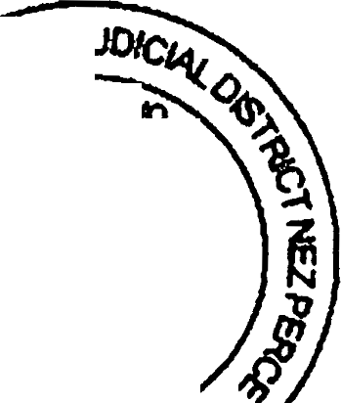

DeutyClerk

•

**FF'c**

AUDITOR ANO RECORDER

0

**tE F**

EXHIBIT "A"

**AFTER RECORDING RETURN TO:**

IDEA Law Group, LLC 4530 S. Eastern Ave., Ste. 10 Las Vegas, NV 89119

Instrument# 912874

NEZ PERCE COUNTY IDAHO

03-04-2024 01 21 10 PM No of Pa!les 2

Reeorded for IDEA LAW GROUP, LLC PATTY WEEKS Fee $15.00

Ex-Otficio Recorder Deputy Mykayla Flores

Index lo: TRUSTEE DEED 1105)

Electronil:a!ly **Recorded by** S,mplillle

Jeremy L. Bass, 480-13908

**TRUSTEE'S DEED**

**The GRANTOR, Janaya 1,. Carter,** as presen1 Tmstec under that Deed of Trust, as hereinafter panicularly described, in consideration of the premises and payments, recited below, hereby grants and conveys without warranty to **DPW Enterprises LLC and Mounlain Prime 2018 LLC, 10028 S. Morgan Grove Way, Sandy, UT 84092, GRANTEES,** that real property, situated in Nez Perce County, State of Idaho, described as follows

The East 25 feet of Lot 9 and all of Lot 10, Block 10 of Maplewood Addition to the City of Lewiston, according to the recorded plat thereof Records of Nez Perce County, Idaho

AJso known as: 15 I 5 21st Ave., Lewiston. ID 83501-3926

**Assessor's Property Tax Parcel/Arcount Number(s):** RPL08800I00IOA

This conveyance is made pursuant 10 the powers conferred upon Trustee by that cenain Deed of Trust between Jeremy L Bass, a married man as his sole and separate property as Grantor, for the benefit and security of Mortgage Electronic Registration Systems. Inc.. as beneficiary. as nominee for Bank of America, N.A.. its successors and assigns as Beneficiary, dated October 16, 2009 recorded on October 30, 2009 as Instrument No 774964 in the mortgage records of Nez Perce County, Idaho, and after the fulfillment of the conditions specified in said Deed of Trust authorizing this conveyance as follows:

* 1. Default occurred in the obligations for which said Deed of Trust was given as security and the Beneficiary made demand upon the said Trustee to sell said property pursuant to the tenns of said Deed of Trust.

Notice of Default was recorded as Instrument No 902262, Mortgage Records of Nez Perce County, Idaho, and in the Office of the Recorder of each county in which the property described in said Deed ofTnist, or any pan thereof. is situated, the nature of such default being as set forth in said Notice of Default Such default still existed at the time of sale

* 1. After recordation of said Notice of Default, Trustee gave notice of the time and place of the sale of said property by registered/certified mail, return receipt requested, by personal service upon the occupants of said real property and/oi- by posting in a conspicuous place on said premises and by publishing in a newspaper of general circulation in each of the counties in which the property is situated as more fully appears in Affidavits recorded at least 20 days prior to date of sale as Instrument Nos. 904186, 904187, 904188, 904189, and 904190, Mongage Records of Nez Perce County, Idaho.
  2. The provisions. recitals and contents of the Notice of Default referred to in paragraph (a) supra and of the Affidavits refem.'11 to in paragraph (b) supra shall be and there are hereby incorporated herein and made an integral part hereof for all purposes as though set forth herein at length.
  3. All requirements of law regarding the mailing. personal service, posting, publication and recording of Notice of Default, and Notice of Sale and all other no1ices have been complied with.
  4. Not less than 120 days elapsed between the giving of Notice of Sale by registered or certified mail and the sale of said propeny

TRUSTEE"S DEED • I

**t,us, llUU'AJ•**

**ID•Trmffe"S *Dt-tO* 1.tAdcr**

**9')2874**

* 1. Trustee. at the time and place of sale fixed by said notice, at public auction, in one parcel, struck off to Grantee. being the highest bidder therefore, the property herein described for the sum of $165,346.71 subjec, however to all prior liens and encumbrances. No person or corporation offered to take any part of said property less than the whole thereof for the amount of principal, interest, advances and costs

IN WITNESS WHEREOF, The Trustee. has caused his/her name to be hereunto subscribed to this Ist_ day of March, 2024

Florida

State of -------··----

County of Lee County

)

) ss:

)

**By** •-·

J:.ma a L. Caller. 118226

Attorney and Successor Trustee

On this 1st day of Mnrch. 2024. personally appeared Janaya L Carter. ,..ho ackno,,Jcdgcd that she signed the within foregoing instrument as her free and \Olunmry act and deed for the uses and purposes therein mentioned.

IN WITNESS WHEREOF, 1 have hereunto set mv hand and affixed my official seal. du: da, and

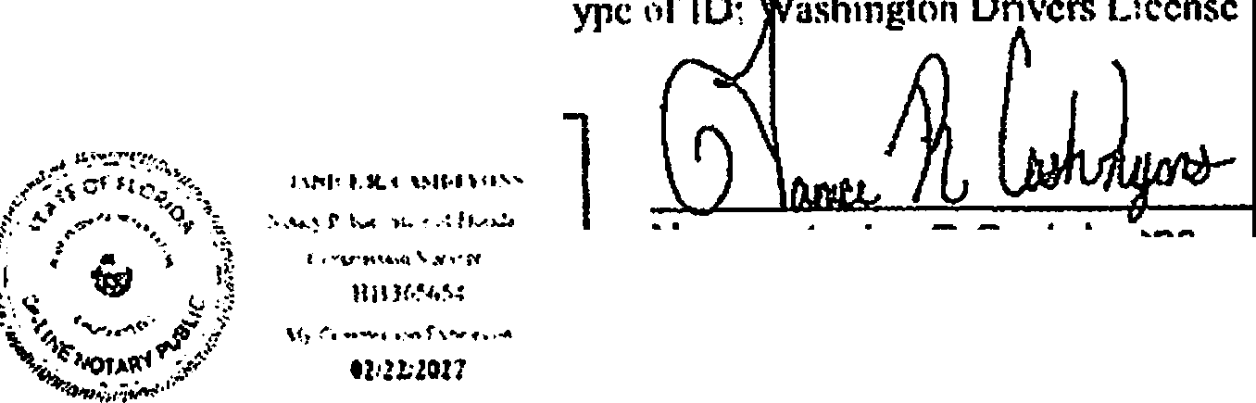

this ccniftcatc first abo\·c written.

•

•

•

Name .Janice R Cash-Lyons

Notary Public for Florida

Residing at Washington Drivers License

Comm1ss1on expires· 02/22/2027

year in

Document ID: 08f3fd29-2170-4f67-994c-e2ebaf5a531c Session ID: 85e97080-25da-4f82-ba51-f9ad6feb81f1

This Notarization was conducted using audio/video technology provided by eNotaryLog, LLC

TRUSTEE'S DEED • 2

1w1.iisuH II

IO-Tnmo:·s Oe-cd 1-t •

EXHIBlT "B"

NOTICE OF EVICTION AND

THREE DAY DEMAND TO VACATE THE PROPERTY

Jeremy L. Bass

## AND ALL OTHER OCCUPANTS

*1515* 21st Ave.

Lewiston, ID 83501

YOU ARE **HEREBY** NOTIFIED that the premises you are occupying was sold at a foreclosure sale on February 29, 2024 and was purchased by DPW Enterprises LLC and Mountain Prime 2018 LLC ("Property Owner"). A copy of the Trustee's/Sheriff's Deed is attached to this Notice. Pursuant to Idaho Code§ 45-1506(11) the Property Owner is entitled to possession of the below referenced property after IO days of the foreclosure sale.

The real property to which the Notice of Eviction pertains is commonly known as 1515 21st Ave., Lewiston, ID 83501, and is more particularly described as follows:

The East 25 feet of Lot 9 and all of Lot 10, Block 10 of Maplewood Addition to the City of Lewiston, according to the plat thereof. Records of Nez Perce County, Idaho.

Demand is hereby made upon you to move out and vacate these premises within three (3) calendar days from the date of the service of this Notice upon you. At the time of moving out, you should remove all of your personal property and leave the premises clean. If you fail to move out within said three (3) calendar days, an eviction action will immediately be filed against you requesting immediate possession of the Property and damages for your detainer.

If you are a tenant of the former owner of the property, and not a child, spouse, or parent of the former owner of the property, you may be entitled to additional rights as provided in the Protecting Tenants at Foreclosure Act of 2009. In order for us to determine on behalf of the Property Owner what rights you may have under the Protecting Tenants at Foreclosure Act of 2009, you must immediately forward to us the following:

1. a copy of your written lease (if an oral lease you must provide us a summary of the tenns of your oral lease, including: the terms of the lease, monthly rental amount, and all other relevant least tenns);
2. proof of your alleged monthly rental amount (proof may be in the form of a copy of you lease showing the rent amount, or, if an oral lease, copies of cancelled checks or money orders);
3. proof that all monthly rental payments due under the lease have been paid to date (proof may be in the form of copies of cancelled checks, money orders, or a signed statement from your landlord stating that you have paid your rent in full as required by your lease);
4. the names of all occupants of the Property who are over 18 years of age; and
5. indicate whether you are a Section 8 tenant.

If you are detennined to be a bona fide tenant with an expired lease, the Property Owner hereby provides notice that your right to remain at the property expires no later than 90 calendar days after the service of this Notice. If you arc still in possession of the property at that time, the Property Owner will immediately begin eviction proceedings against you.

If you believe you are a bona fide tenant with a unexpired lease or a bona fide tenant with

ID2 l**698.NTV**

an expired lease, you are required to make your required monthly lease payments during the remainder of your lease agreement if your lease is unexpired and/or during the 90 day notice of eviction period if your lease is expired.

If you are an active service member, or a dependent of an active service member of the United States Armed Forces, you may be entitled to rights as provided in the Servicemembers Civil Relief Act. In such case, you or your attorney should immediately provide proof of military service to this law firm to determine eligibility and verify if you fall under the protection of this Act.

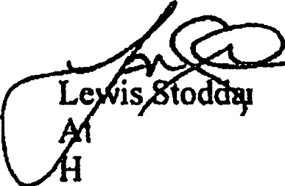Please govern yourselves accordingly. Dated this day of March, 2024.

d

to,-....,..tn roperty Owner aJliday, Watkins & Mann, P.C.

300 W. Main St., Ste. 150

Boise, ID 83702

Telephone: 801-355-2886

File No. 1D21698

**!021698.NTV**